](https://jhovious.github.io/team2cs334.github.io/Part%202/templates/cart.html)

<https://jhovious.github.io/team2cs334.github.io/Part%202/templates/login.html>

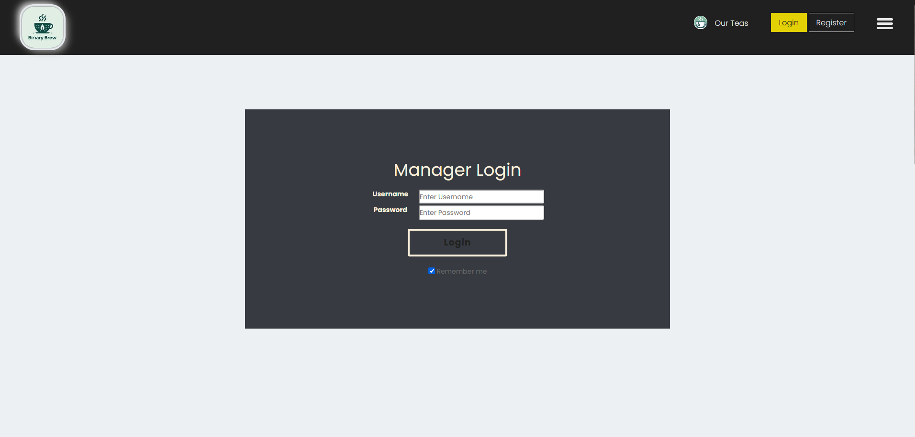

<https://jhovious.github.io/team2cs334.github.io/Part%202/templates/Manager_Menu.html>

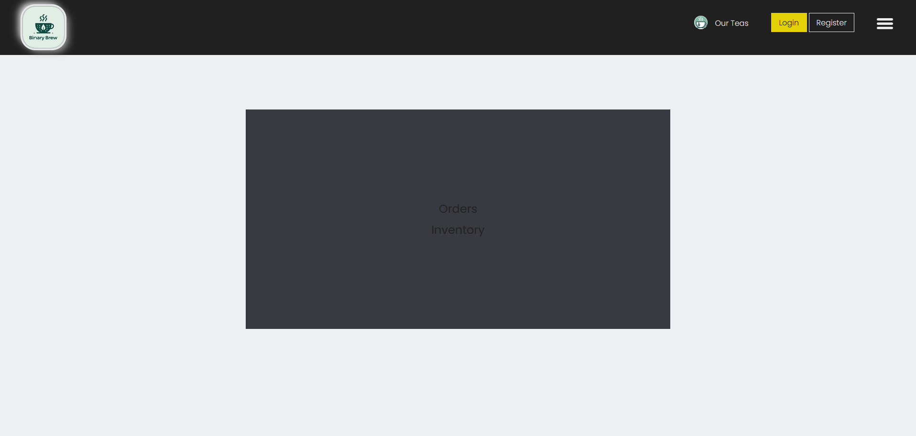

<https://jhovious.github.io/team2cs334.github.io/Part%202/templates/Orders.html>

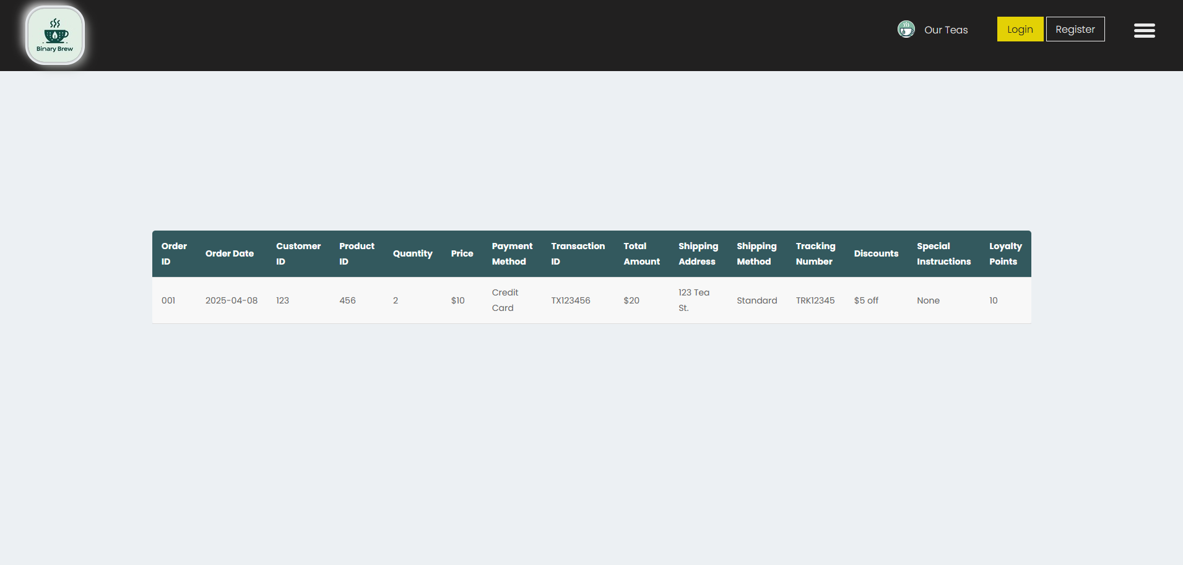

<https://jhovious.github.io/team2cs334.github.io/Part%202/templates/Inventory.html>

